

**Drink & Delight**

**Inventory Management System**

Table of Contents

1. Introduction
2. Overview
3. Team Member Work Allocation-------------------------------------------------------------
4. Epic & Stories -----------------------------------------------------------------------------------
5. Use Cases ----------------------------------------------------------------------------------------
   * 1. Authentication -----------------------------------------------------------
6. Login ---------------------------------------------------------------------
7. Forgot Password ----------------------------------------------------------------
8. Logout------------------------------------------------------------------------------

2) Raw Material/ Product Order Management ----------------------------------------

a) Place an Order ---------------------------------------------------------------------

b) Update an Order------------------------------------------------------------------

c) Display Order Details--------------------------------------------

d) Display Supplier Details--------------------------------------------------------

e) Display Distributor Details----------------------------------------------------

3) Stock Management

a) Set process date/Exit date--------------------------------------------------------

b) Update Stock------------------------------------------------------------------------

c) Track Order--------------------------------------------------------------------------

1. Class Diagram -----------------------------------------------------------------------------------
2. ER Diagram---------------------------------------------------------------------------------------
3. Test Case Scenario -----------------------------------------------------------------------------
4. BDD------------------------------------------------------------------------------------------------
5. Conclusion----------------------------------------------------------------------------------------

4. Epic & Stories

|  |  |  |  |  |
| --- | --- | --- | --- | --- |
| Epic | Stories | As a/an | I want to | So that |
| Authentication System | Login | User | Enter my correct  credentials and login | I will successfully login to the system |
|  | User | Enter my incorrect credentials and login | I will not be able to successfully login to the system |
| Forgot Password | User | Change my password if I have forgotten my password | I can successfully change my password to a new one |
| Logout | User | Come out of my system | I will be successfully be able to logout of the system |
| Track Raw Material Order | Track  Order | User | Enter Order Id  of Raw material | I get all the details about that particular order Id |
| Update Raw Material Stock | Set Process Date | User | Enter RM Order Id and process date for that Id | Process date is inserted in database and data inserted message is shown |
|  | Update Manufacturing Date, Expiry Date & QA | User | Enter RM order Id and set Manufacturing Date, Expiry Date & QA for that Id | All details are inserted in database and data inserted message is shown |
| Track Product Order | Track  Order | User | Enter Order Id  of Product | I get all the details about that particular order Id |
| Update Product Stock | Set Exit Date | User | Enter Order Id  of Product and exit date for that Id | Exit date is inserted in database and data inserted message is shown |
|  | Update Manufacturing Date, Expiry Date & QA | User | Enter product  Order Id and  set Manufacturing Date, Expiry Date & QA for that Id | All details are inserted in database and data inserted message is shown |
| Update an  Order | Update  Delivery  Status of Raw  Material Order | User | Enter Raw  Material Order Id and new Delivery Status | The delivery status of that Order is set and the same is reflected in the database. |
|  | Update  Delivery  Status of Product Order | User | Enter Product  Order Id and new Delivery Status | The delivery status of that Order is set and the same is reflected in the database. |
| Place an order | Place Raw Material Order | User | Enter all the details for a Raw Material Order | Raw Material Order is placed successfully. |
|  | Place Product Order | User | Enter all the details for a Product Order | Product Order is placed successfully. |
| Display order details | Display Raw Material Order Details | User | Enter delivery status, supplier ID, start and end date(optional). | I get all the details of all the raw material orders placed. |
|  | Display Product Order Details | User | Enter delivery status, distributor ID, start and end date(optional). | I get all the details of all the product orders placed. |
| Display Supplier Details | Display Details of Supplier | User | Enter Supplier  ID | I get all the details of the specified Suppliers. |
| Display  Distributor Details | Display Details of Distributor | User | Enter Distributor  ID | I get all the details of the specified Distributors. |

5. Use Cases

5.1 Authentication System

Overview

A login is a set of credentials used to authenticate a user. Most often, these consist of a username and password. However, a login may include other information, such as a PIN number, passcode, or passphrase. Some logins require a biometric identifier, such as a fingerprint or retina scan.

Logging in is usually used to enter a specific page, website or application, which trespassers cannot see. Once the user is logged in, the login token may be used to track what actions the user has taken while connected to the site. Logging out may be performed explicitly by the user taking some actions, such as entering the appropriate command, or clicking a website link labelled as such. It can also be done implicitly, such as by the user powering off his or her workstation, closing a web browser window, leaving a website, or not refreshing a webpage within a defined period.

Prerequisite

User must login as USER to perform the required functionalities for Raw material and Products for our client Drink and Delight.

Non-Functional Requirement:

* Performance Requirements: ​

User can login in < 10 seconds​

All ad hoc reports should be published in < 5 seconds​

Customer Order screen should be able complete submission of customer order within 3 sec including all validations on shipping address. ​

Customer Address List screen should not take more than 2 sec​

* Operations and Reliability: ​

Up time requirement​

Acceptable data loss​

System update​

Designed and Implemented By:

Akash Deep

(Id: 46001763)

Designation: Senior Analyst

Use Case Diagram for Authentication

A close up of a logo

Description generated with high confidence

a) Login

This module has been designed to login into the database. This can be only accessed by employee with correct credentials.

Sequence Diagram for Login

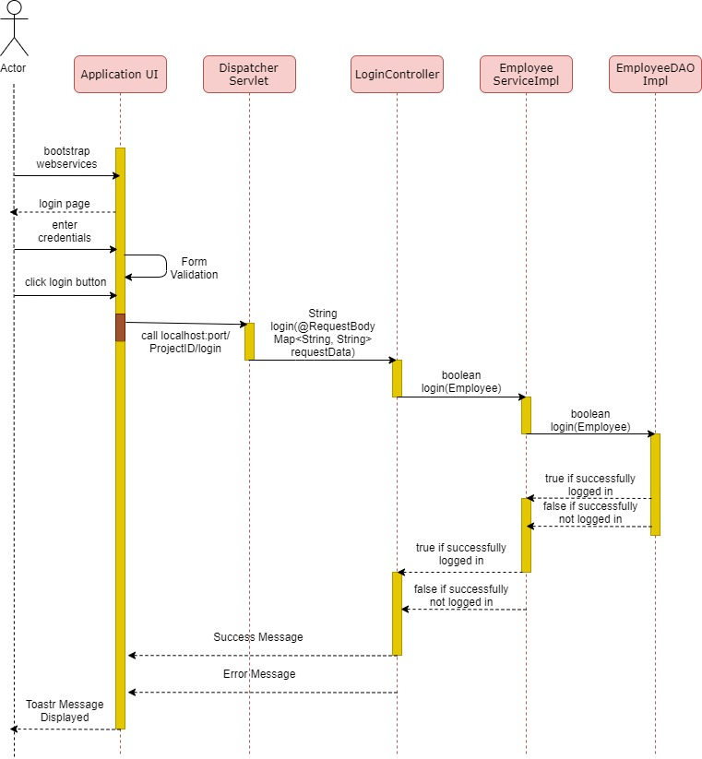

* 1. ForgetPassword

If the user logins into the system with incorrect credentials then he/she needs to change password the we have a functionality which you can see in the code where we can change the password manually, by giving some security questions and answers that will be specific for each user in order to change their password.

Sequence Diagram for changing the password

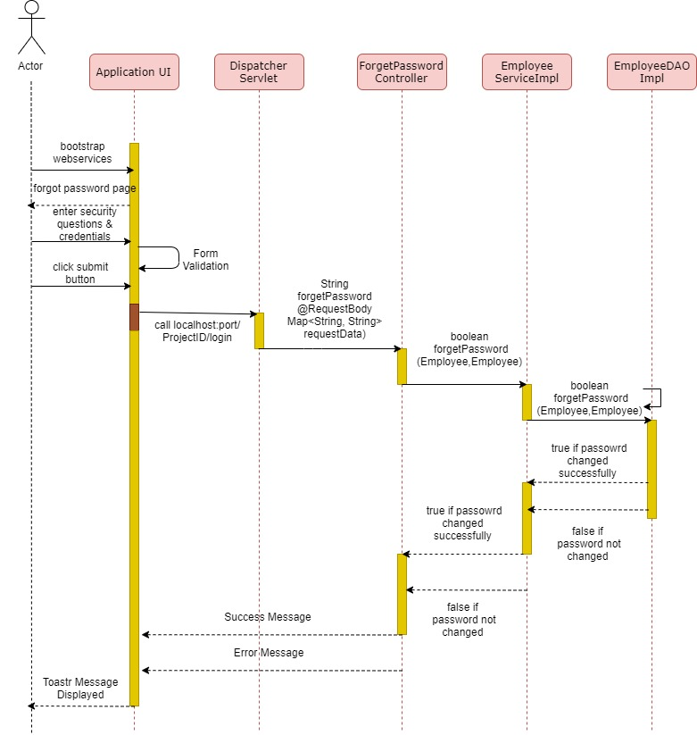

* 1. Logout

User here can simply logout from the UI as you can see the frontend code part where by using angular we can directly logout.

So, no sequence diagram is required for it.

Sequence Diagram for Track Raw Material Order and Update Raw Material Stock

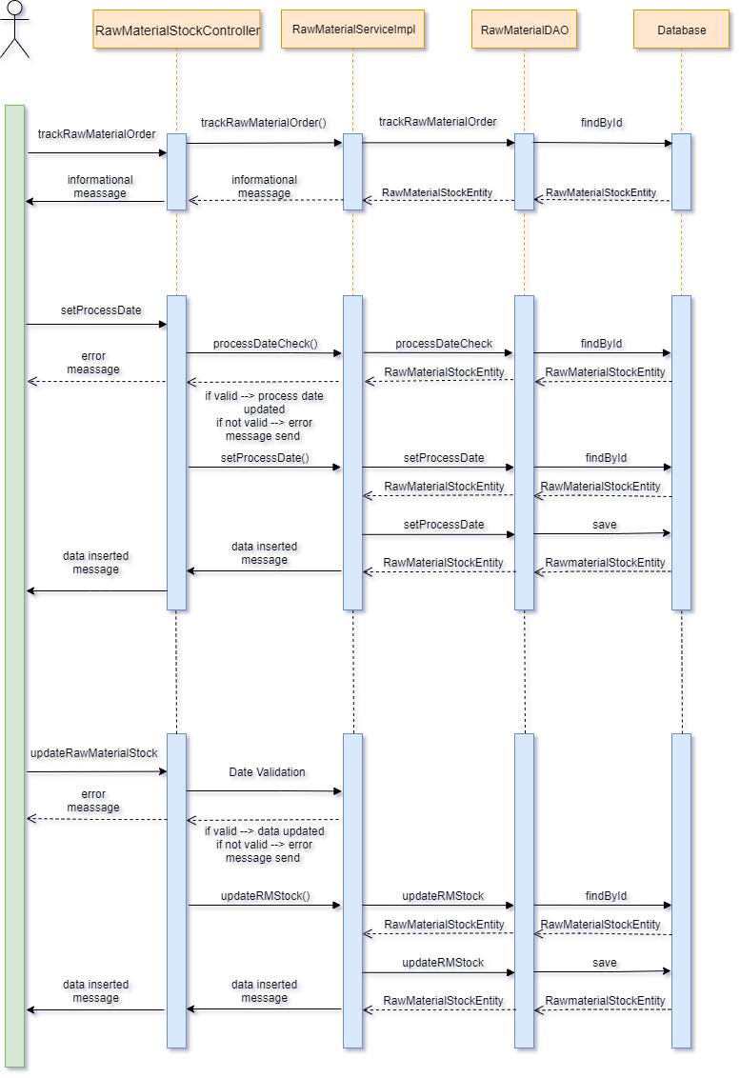

Sequence Diagram for Track Product Order and Update Product Stock

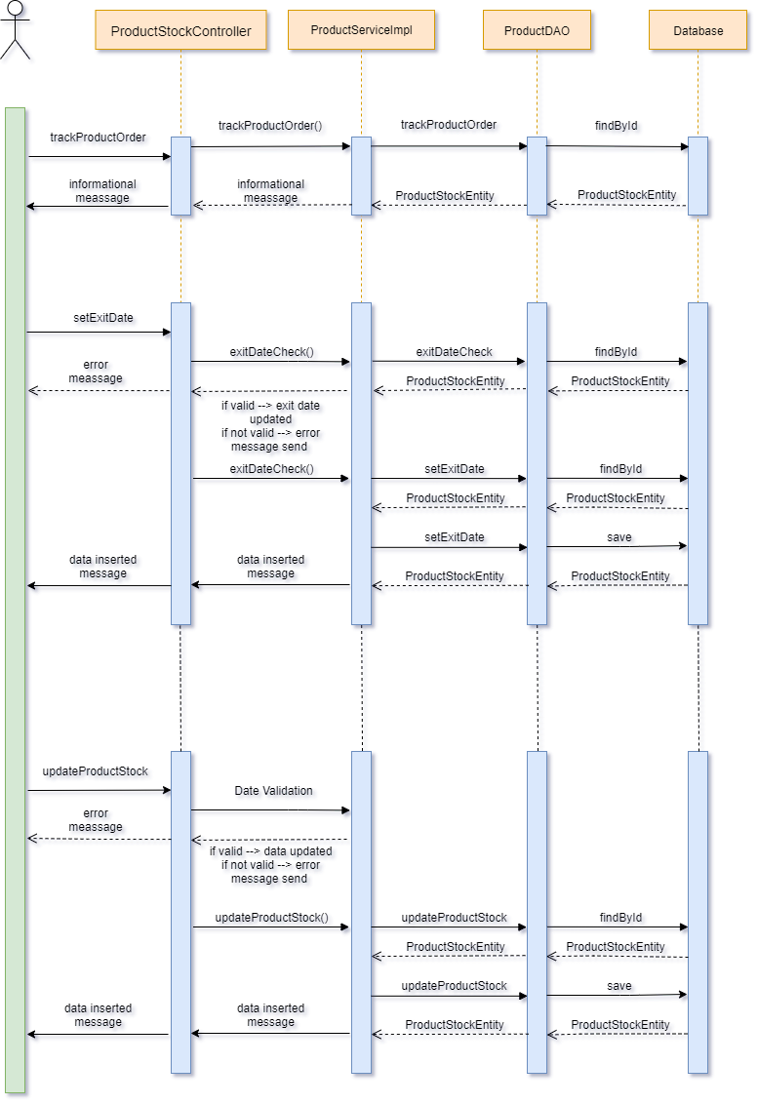

5.2 Raw Material/ Product Order Management

Overview

The life cycle of a Raw material/ Product Order is handled in this case. This includes placing an order, updating the order (if necessary) and displaying the order. The management of supplier and distributor details is also considered.

Prerequisite

User must as USER should be able to perform the required functionalities of Order Management for Raw material and Products for our client Drink and Delight.

Designed and Implemented By:

Prathamesh Pai

Akhil Moluguri

Masharib Hussain

Ankit Kumar

Ashwani Pandey

Ashmita Das

(Id: 46001536)

Designation: Senior Analyst

Use Case Diagram for Raw Material Orders/Stocks

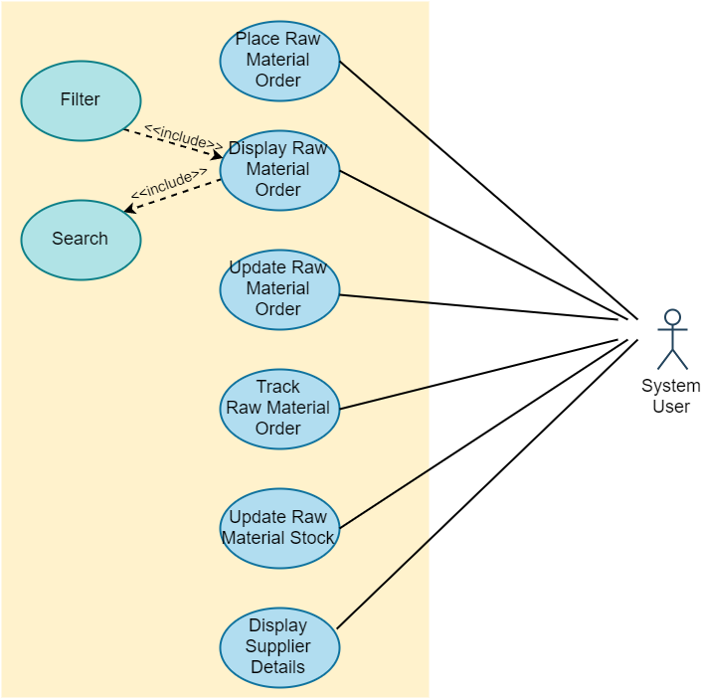

Use Case Diagram for Product Orders/Stocks

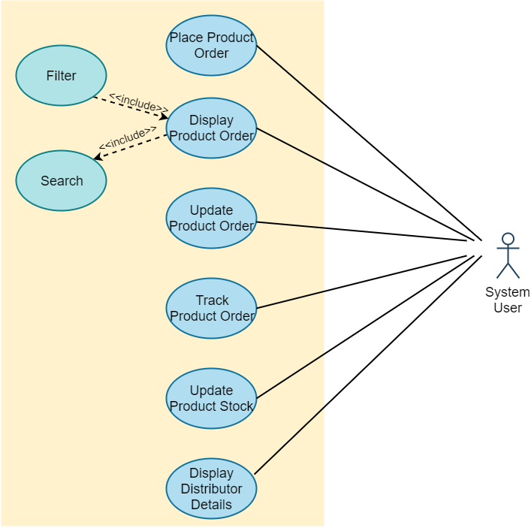

a) Place an Order

When the user clicks on 'Place an order' tab under 'Raw Material' dropdown, the user sees a form to add following Raw Material order details:

* Raw Material Name
* Supplier ID
* Warehouse ID
* Quantity value and unit
* Price per Unit
* Expected Date of delivery

Now there is a Submit button that the user needs to click which would allow the send the request to the Rest Controller at the backend.

Here, the values in the dropdowns of Raw Material Name, Supplier ID, Warehouse ID are loaded from the backend when the page is loaded. Also, date is restricted in such a way that the user can enter a date before 2 months from the current date. Thus, the user cannot enter a past date or a date after 2 months from the current date. The Quantity value and Price per Unit values need to be number and the field cannot be empty. This has been handled in the Angular Component.

Sequence Diagram for Place Raw Material Order

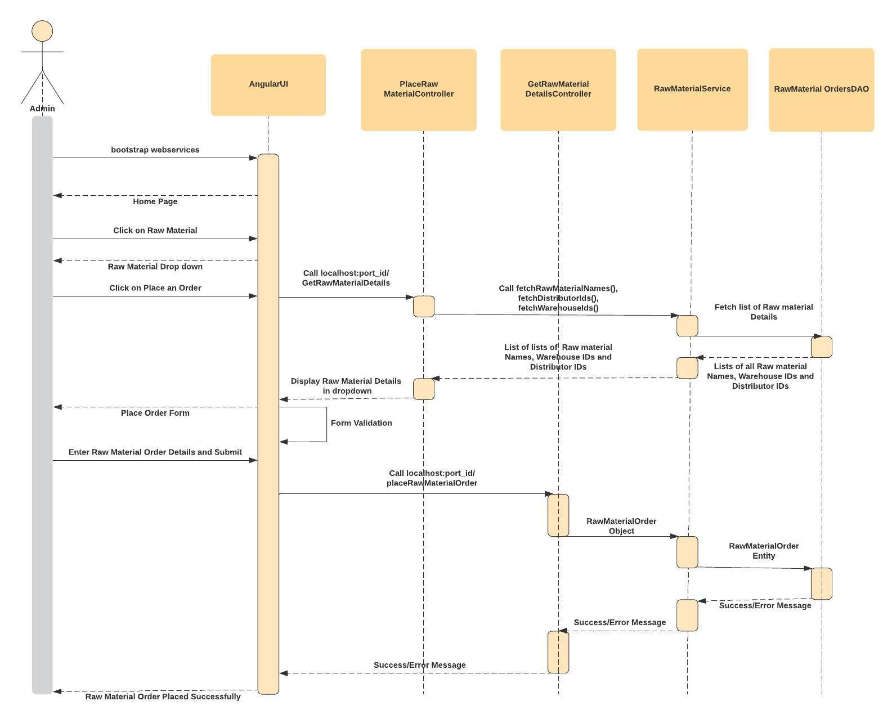

Sequence Diagram for Place Product Order

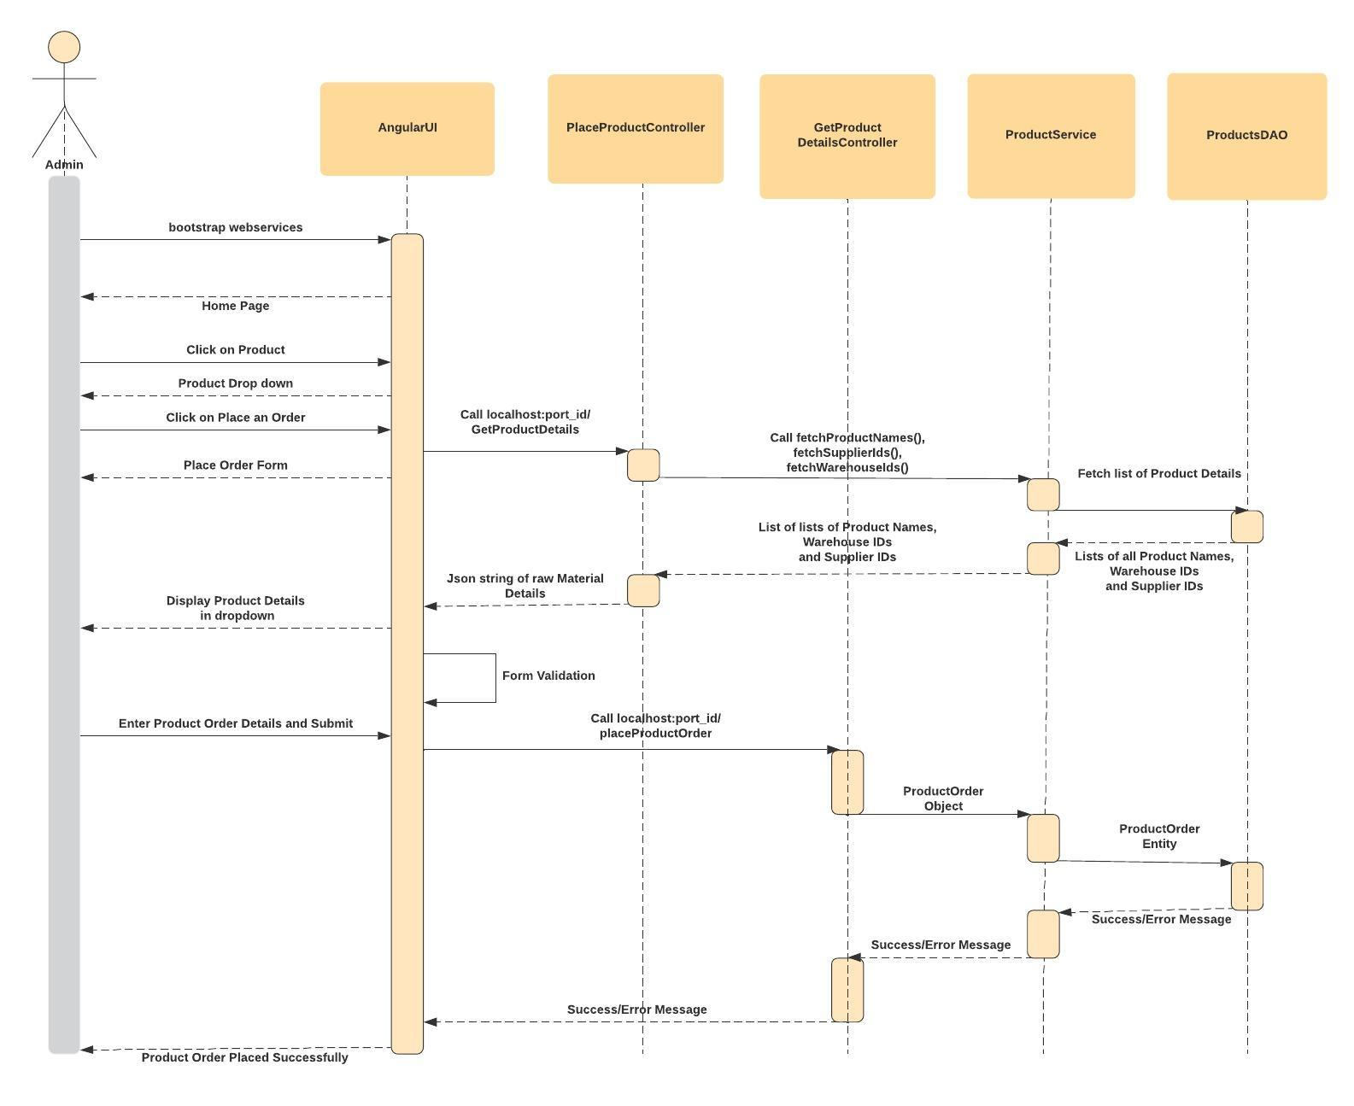

b) Update an Order

When the user clicks on 'Update an order' tab under 'Raw Material' or ‘Product Order dropdown’, the user sees a form to update delivery status of an Order :

* Raw Material Order Id/ Product Order Id
* Delivery Status

Now there is an Update Order button that the user needs to click which would allow the send the request to the Rest Controller at the backend and change delivery status in database.

Sequence Diagram to Update Delivery Status of Raw Material Order

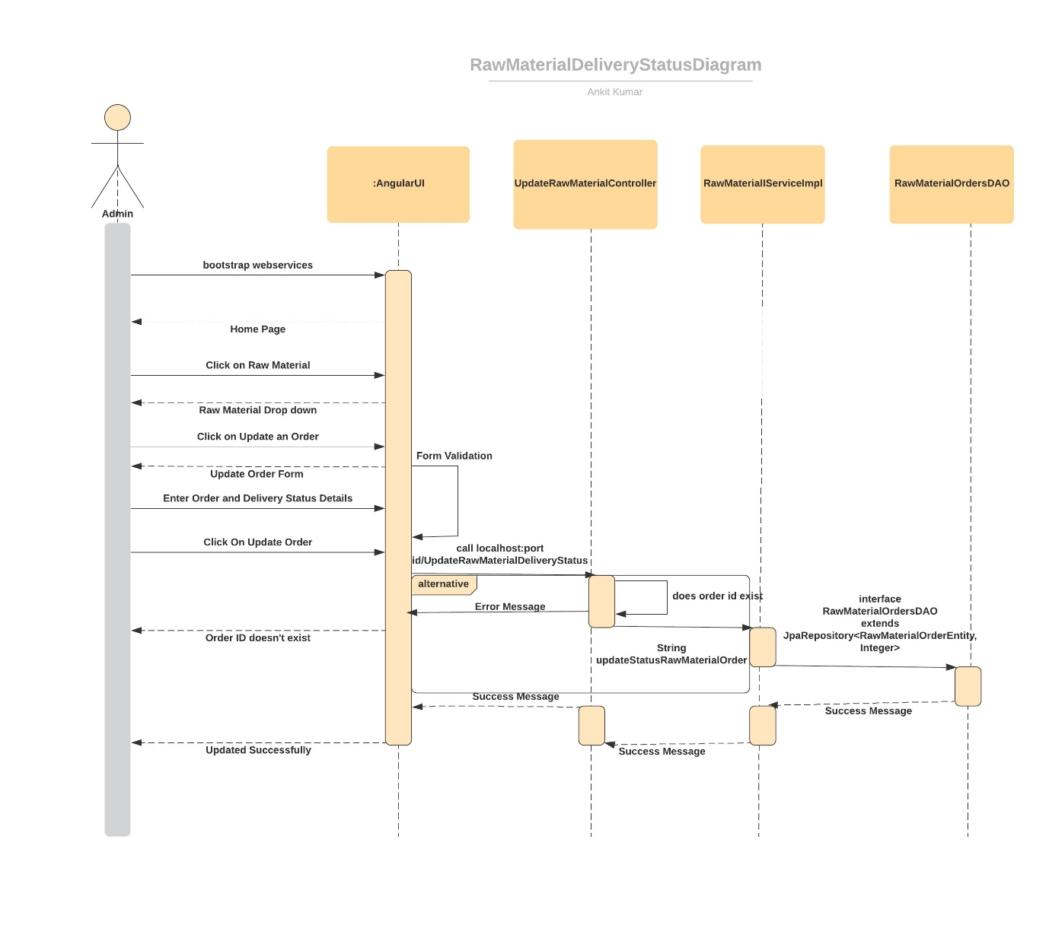

Sequence Diagram to Update Delivery Status of Product Order

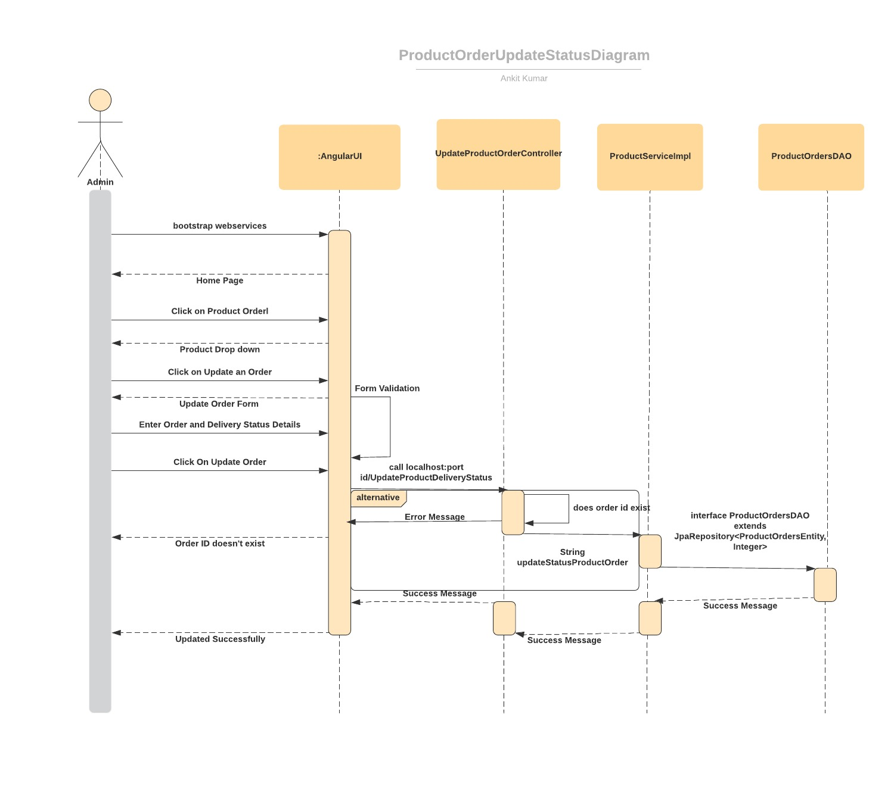c) Display Order

1.Raw Material

When the user clicks on 'Display Raw Material ' tab under 'Raw Material' dropdown, the user sees a form to submit the required details:

* Supplier ID
* Delivery Status
* Start Date - Optional
* End Date - Optional

Now here the user has the option to select the date range between which he wishes to display the orders. Finally, to submit the form user clicks on the Submit which would send the request to the Rest Controller at the backend.

Here, the values in the dropdowns of Supplier ID and Delivery Status are fixed in the angular html Template. Also, Start Date and End Date are restricted in such a way that the user can enter a date after 2019 January and the Max Date allowed is the current Date. . This has been handled in the Angular Component.

Sequence Diagram for Display Raw Material Orders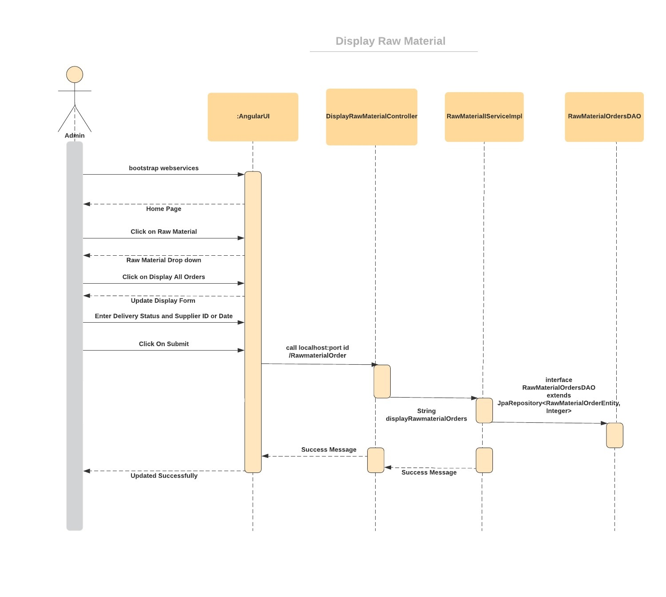

2.Product

When the user clicks on 'Display Product ' tab under ' Product ' dropdown, the user sees a form to submit the required details:

* Distributor ID
* Delivery Status
* Start Date - Optional
* End Date - Optional

Now here the user has the option to select the date range between which he wishes to display the orders. Finally, to submit the form user clicks on the Submit which would send the request to the Rest Controller at the backend.

Here, the values in the dropdowns of Distributor ID and Delivery Status are fixed in the angular html Template. Also, Start Date and End Date are restricted in such a way that the user can enter a date after 2019 January and the Max Date allowed is the current Date. . This has been handled in the Angular Component.

Sequence Diagram for Display Product Orders

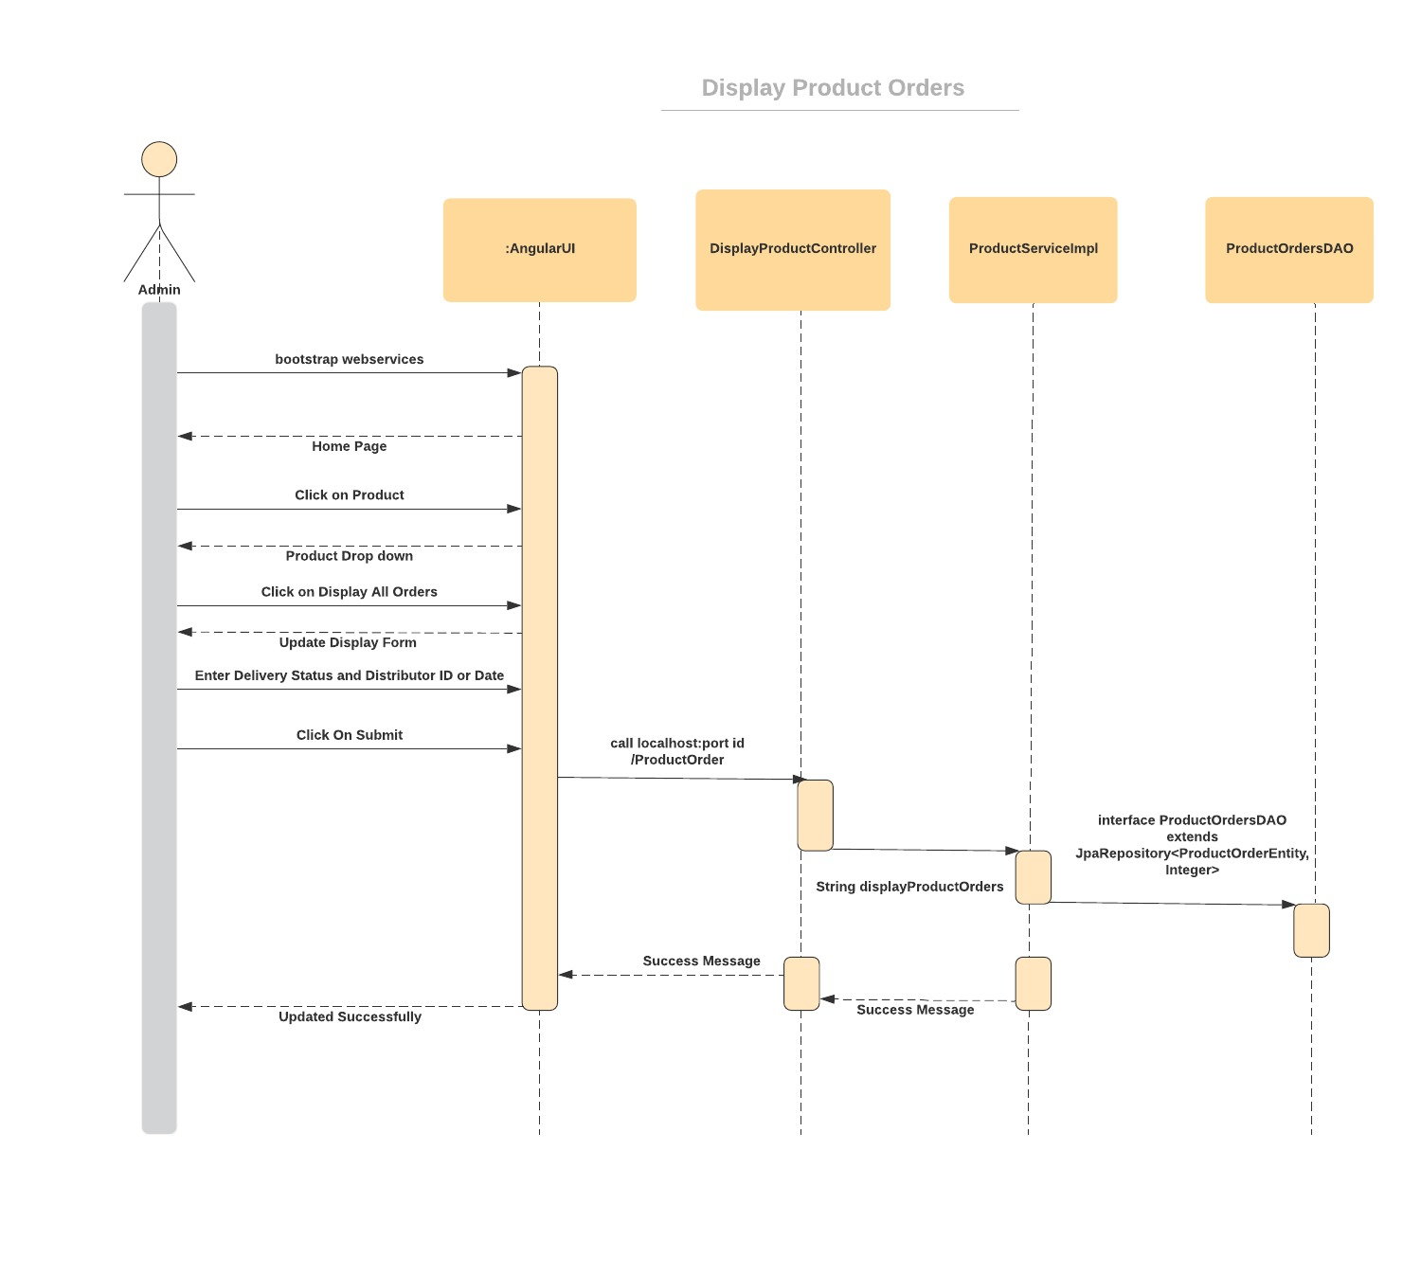

d) Display Supplier Details

When the user clicks on 'Display Supplier ' tab under 'Raw Material' dropdown, the user sees a dropdown to select the required supplier Id.

Now here the user has to select the desired supplier Id whose details he would like to see. Here, the values in the dropdowns of Supplier ID is fixed in the angular html Template. This has been handled in the Angular Component.

Finally, he clicks on the Submit button which would send the request to the Rest Controller at the backend.

The table with all the details (Supplier Id, Name, Address, Phone No.) of that particular supplier is displayed.

Sequence Diagram for Display Supplier Details 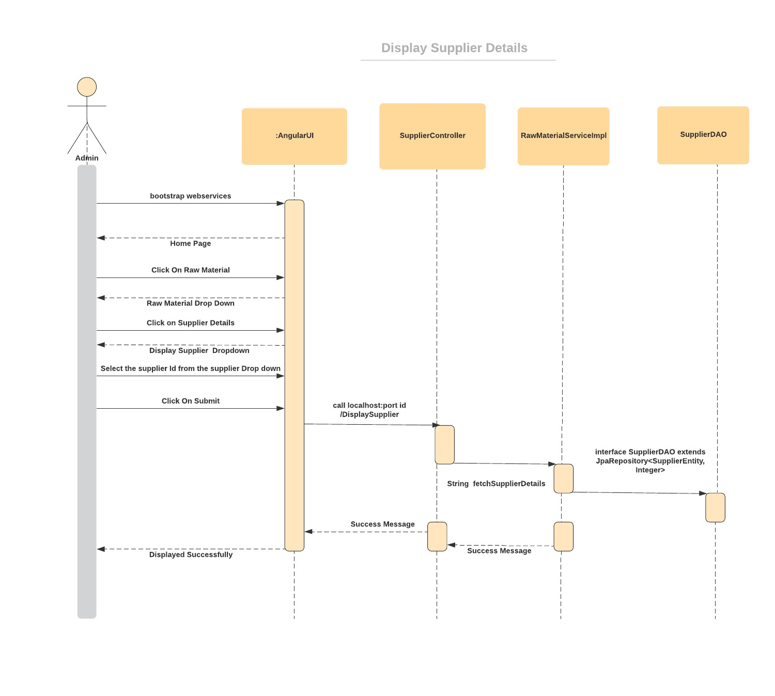

e) Display Distributor Details

When the user clicks on 'Display Distributor ' tab under 'Raw Material' dropdown, the user sees a dropdown to select the required supplier Id.

Now here the user has to select the desired distributor Id whose details he would like to see. Here, the values in the dropdowns of Distributor ID is fixed in the angular html Template. This has been handled in the Angular Component.

Finally, he clicks on the Submit button which would send the request to the Rest Controller at the backend.

The table with all the details (Distributor Id, Name, Address, Phone No.) of that particular Distributor is displayed.

Sequence Diagram for Display Distributor Details

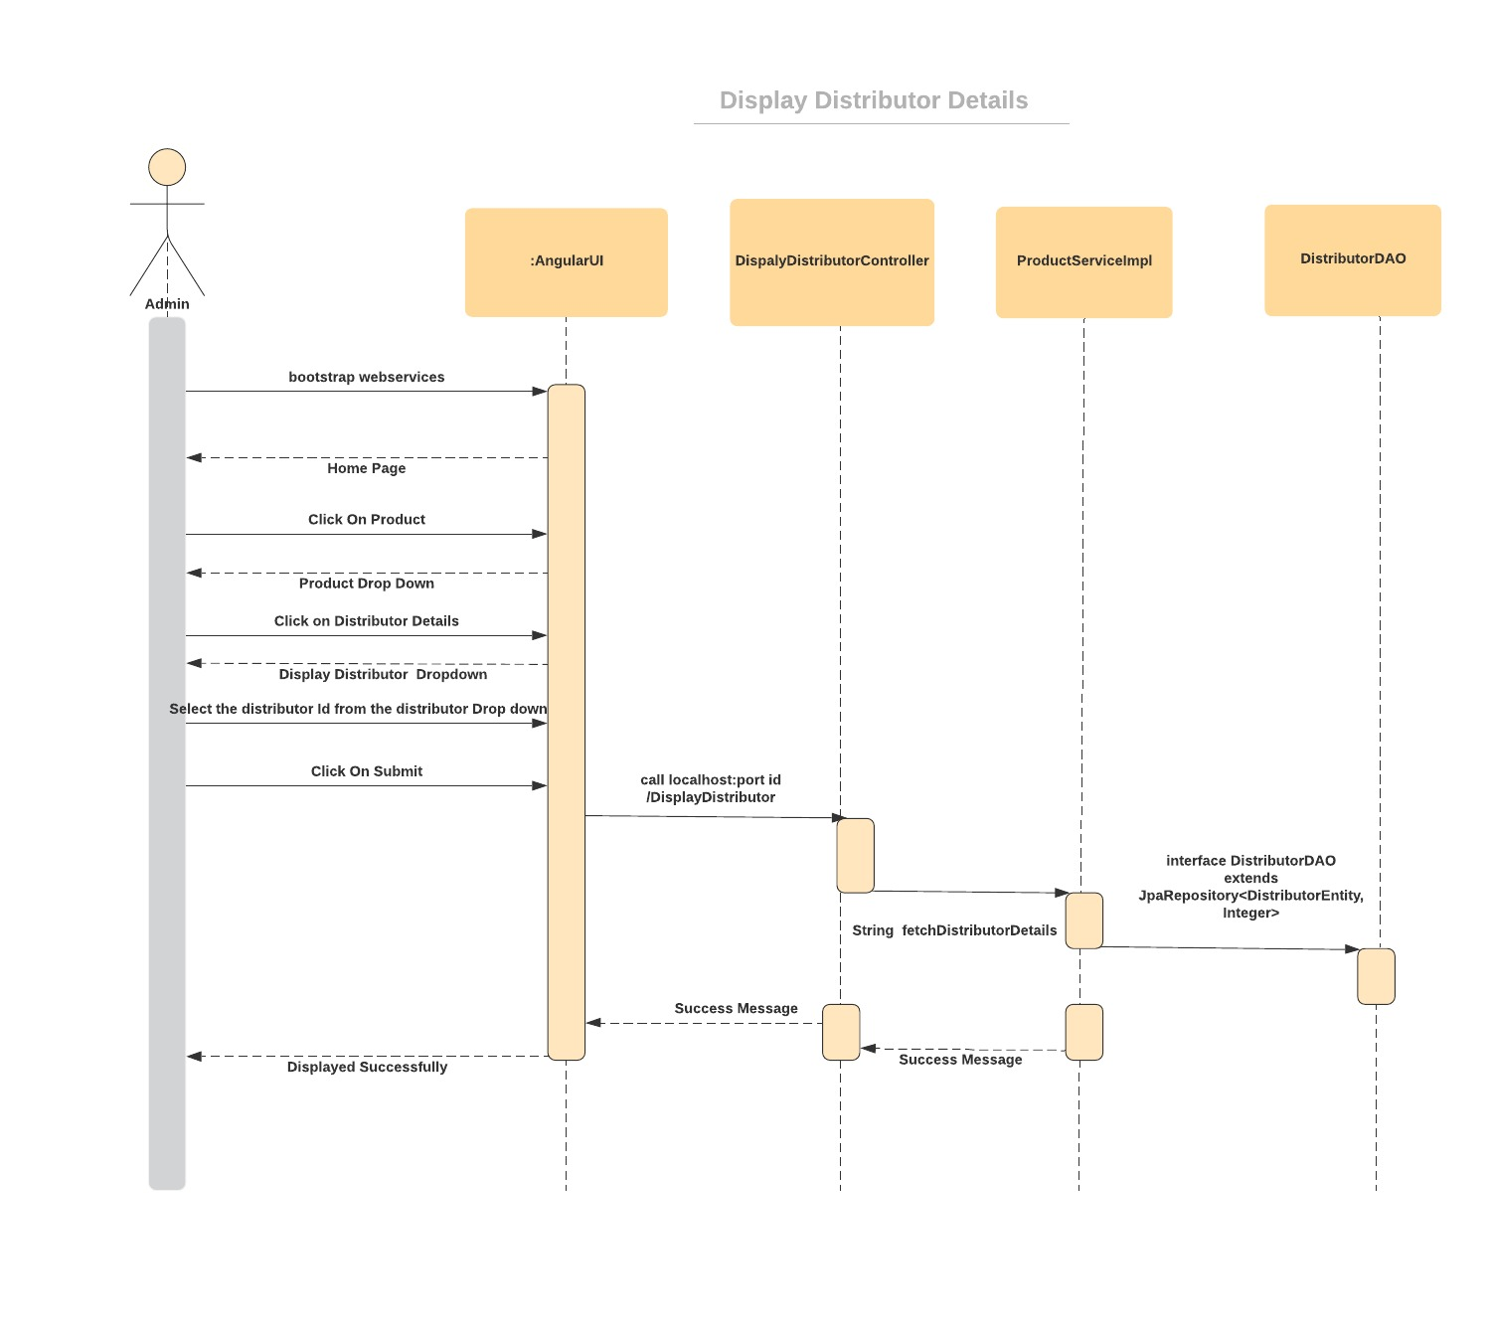

5.3 Raw Material/ Product Stock Management

Overview

The life cycle of a Raw material/ Product Stock is handled in this case. Updating of Stock inventory according to the received order of raw material/product is done. Functions include set process date for raw material, set exit date for product, update other stock details (manufacturing date, expiry date and quality status) for both raw material and product. Track time and location of raw material and product is also a function.

Prerequisite

User must as USER should be able to perform the required functionalities of Stock Management for Raw material and Products for our client Drink and Delight.

Designed and Implemented By:

For Product Stock Management:

Diksha Gupta

(Id: 46003707)

Designation: Senior Analyst

For Raw Material Stock Management:

Gaurav Jayant Gaikwad

(Id: 46001535)

Designation: Senior Analyst

Class Diagram for Raw Material Stock Management:

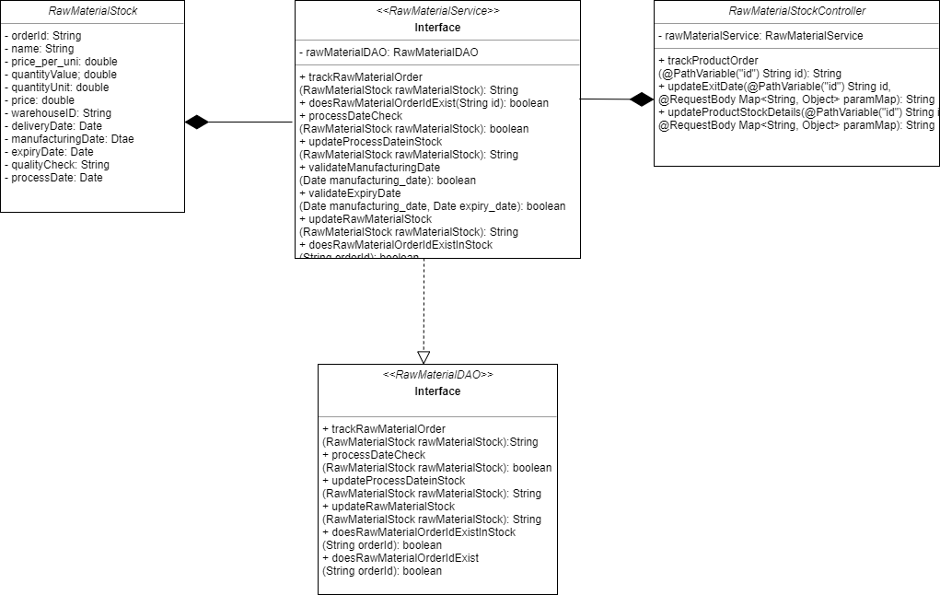

Class Diagram for Product Stock Management:

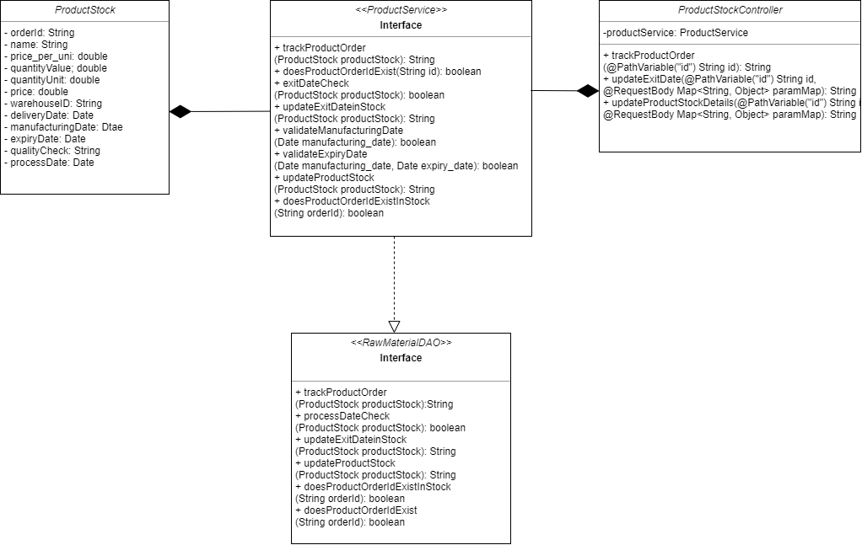

Class Diagram of Login Functionality:

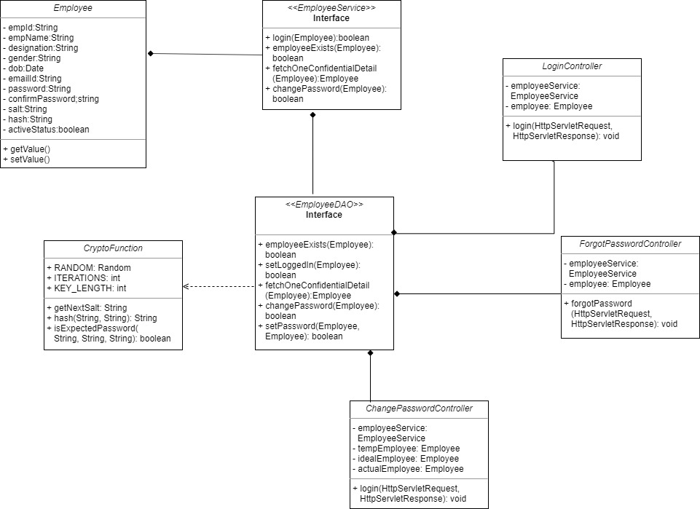

Class Diagram of Raw Material Order management:

